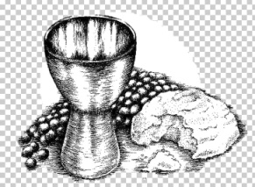
Parish of St Bernard’s, Burnage
Sacrament of Reconciliation and First Holy Communion 2022
Name of Child

Date of Birth

Date of Baptism  Was your child baptised in this Parish? | Yes / No  If not, please give details
Home Address | Postcode
Telephone number | Home  Mobile
Name of Parents or guardians

Religion of Parents or guardians

Email Address

Contact name and number for emergency use | Name  Number
Which School does your child attend?

 | PTO
Does your child have any medical conditions or allergies of which we should be aware? | YES[ Please give details]  NO
Do you give permission for your child to receive first aid if required? | YES  NO
Do you attend Holy Mass in this Parish? | Yes / No *  If no, in which Parish do you worship?
Why do you wish for your child to be prepared for the Sacrament of Reconciliation and Holy Communion?

Please read the following and then sign and date as shown.
- I understand that attendance is compulsory for all sessions and celebrations.

- I understand that it is my responsibility to ensure that my child attends Sunday Mass regularly.

- I undertake to help my child to prepare for the Sacrament through prayer, example, discussion and completion of tasks set as part of the Parish Programme.

- I understand that I will accompany my child and be part of the programme of Preparation.

Signed_______________________________[parent / guardian]

Date________________________

